**User Acceptance Testing (UAT)**

|  |  |
| --- | --- |
| Date | 28 June 2025 |
| Team ID | LTVIP2025TMID53030 |
| Project Name | Learnhub : Your Center For Skill Enhancement |
| Maximum Marks | 4 marks |

**Project Overview:**

Project Name: LearnHub

Project Description: An online learning platform where educators create latest technology courses and learners enroll and learn latest courses online at the comfort of their home.

Project Version: v1.0

Testing Period: June 29, 2025 – July 15, 2025

**Testing Scope:**

Features and functionalities to be tested:

* Courses search & Discovery
* Enrolling in courses
* Marking pages as complete
* Track learning progress
* Educators creating courses
* Responsive UI
* Certificate generation

**Testing Environment:**

URL/Location: localhost:5173

**Test Cases**

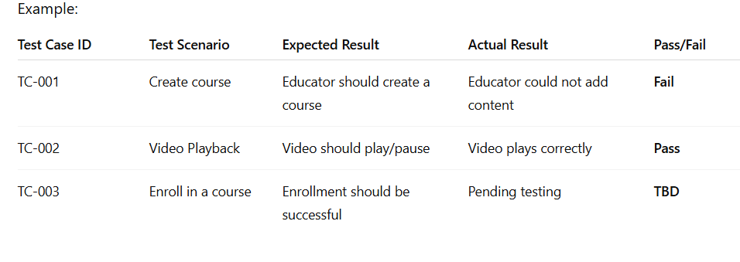

**Bug Tracking :**

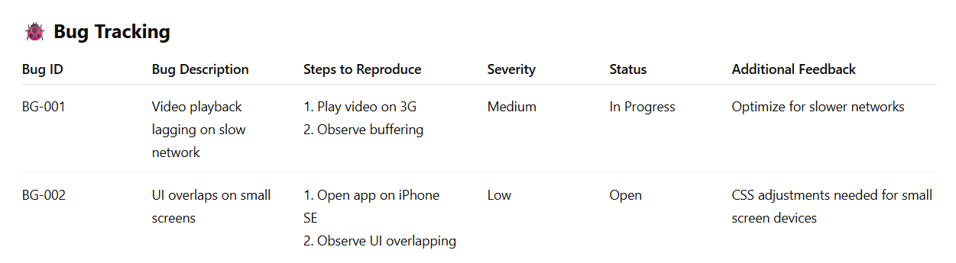

**Sign-off:**

Tester Name: Pallavi

Date: 30-06-2025

Signature: Pallavi